Event 1

**Solution Density / Drop Volume Race**

Competition for one or two members of each team working individually.

Supplies

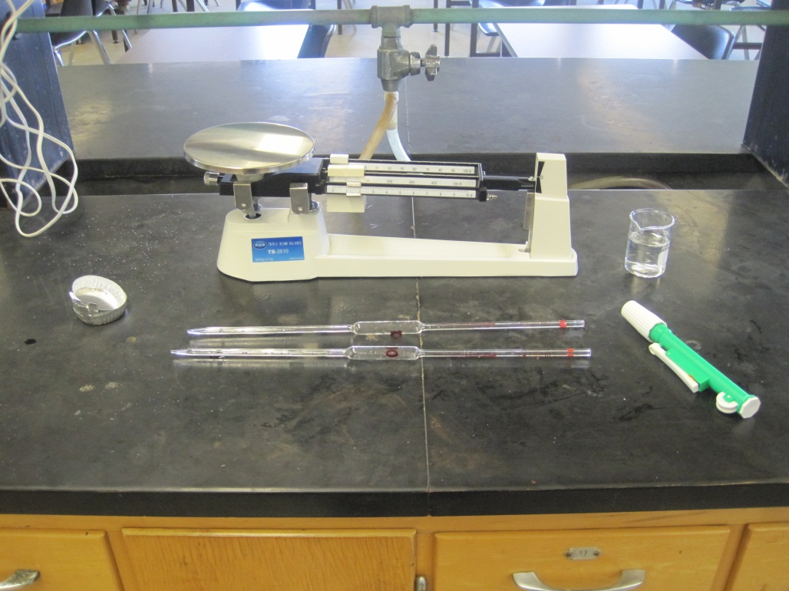

Each student will be provided with a sheet to record their data, a dry empty foil weighing boats, a nontoxic solution of salt water, a pipet, rubber bulb (not shown), pipet helper, and a triple beam balance.

Each participant should bring a pencil, calculator, and safety goggles.

The Competition

Determine the density of a salt water solution and the volume of a single drop of liquid from the pipet.

The Procedure

When the start signal is given, students will weigh the empty weighing boat. They will pipet the liquid (10.000 mL) into the boat and weight them both. This will allow the density of the solution to be calculated.

The student will then weigh a new dry weigh boat. Some number of drops of salt solution will be added to dry weighing boat and the new mass will be determined. From this the volume of a single drop in mL can be calculated. The number of drops is arbitrary, balancing speed and accuracy.

Participants should report to the nearest hundredth of a gram when weighing. Since the pipets used will measure exactly 10.000 mL, they will not limit the number of significant figures.

On the form provided, each person will enter all appropriate data, showing calculations, and then shout “Done!” A Loras College judge will enter the time of the completion and collect the paper.

Scoring

Only the values on provided sheet will be graded, so make sure to be careful during your calculations. Participants will be ranked according to accuracy in intervals of 1.0% deviation of the correct value, then on speed. First place will receive 20 points, second 19, etc. If a team has two participants only the best score will count in the overall team competition.

Event 2

**Periodic Table Race**

Competition for one or two members of each team working individually.

The Competition

Each competitor will be given a partial completed periodic table. Some of the symbols, names, and properties of the elements will be filled in, but some will be left blank. The blank spaces will be numbered. Students will fill in the missing information.

On another sheet, students will be asked questions based on the periodic table covering topics of periodic trends, elemental states, names of families, and basic atomic structure.

When a contestant has completed the table and sheet, they will shout “Done!” a Loras College judge will note the time and collect the sheet.

Scoring

Competitors will be ranked by the number of correctly placed elements and answered questions, and then sub-ranked by time. 20 points will be given to first place, 19 to second place, etc.

Event 3

**Team Titration Race**

Competition for two members of each team working together.

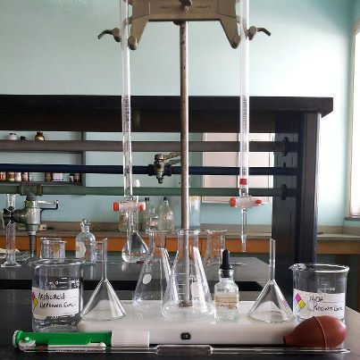Supplies

Each pair of competitors will be provided with two 50 mL burets, a weak acid solution of unknown molarity, a strong base solution of known molarity, two funnels, stirring rod, three 250 mL flasks, dropper bottle of phenolphthalein, and bottle of DI water.

Students should bring goggles, pencil or pen, and a calculator.

The Competition

Determine the concentration of a weak, monoprotic acid with a standardized base with titration.

The Procedure

When the starting signal is given, the acid and base solutions will poured into the burets. Three aliquots of acid will be placed into each of the three 250 mL beakers. The contestants choose the volume of acid (see below). The acid is then titrated with the known concentration base. It is recommended that buret volume readings are kept to two decimal places. As soon as the molarity (to 3 significant figures) of the unknown weak acid has been calculated as the average from all three trials, the contestant may shout “Done!” and a Loras College judge will record the time and immediately collect the completed sheet.

Students will need to decide how much acid to titrate during each trail. Larger volumes of acid will increase accuracy, but will take more time to titrate. Contestants must wear their goggles throughout the competition.

Scoring

The concentration that will be scored is the average concentration value reported only, so make sure to report your answer correctly. Each contestant will be ranked according to accuracy in intervals of 0.4% deviation of the correct value for the unknown acid concentration, and then sub-ranked according to speed. 20 points will be given to first place, 19 to second place, etc. Disqualification for using a crib sheet, breaking a buret or flask, or gaining help from any other individual will result in 0 points.

Event 4

**Solution Identification Race**

Competition for one or two members of each team working individually.

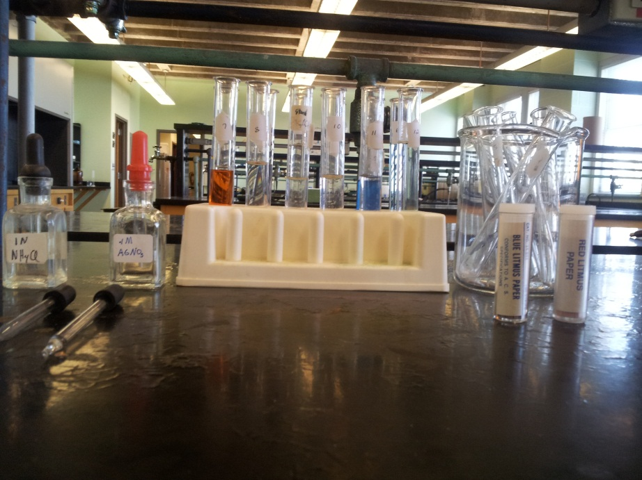Supplies

Students will bring safety goggles and a pen or pencil.

Each participant will be given a set of twelve numbered, but otherwise unidentified, test tubes. Each will contain 5-10 mL of approximately 0.1 M solutions of the following molecules:

HCl, AgNO3, NaCl, BaCl2, Cu(NO3)2, CuSO4, K2Cr2O7, Fe(NO3)3, H2SO4, NaOH, NH4OH, and HNO3.

Each set of solutions will be accompanied by 5 clean test tubes, red and blue litmus paper, and dropper bottles of 0.1 M AgNO3 and NH4Cl. Students MUST wear their safety goggles.

The Competition

Students should use their knowledge of solubility rules and acid/base tests to determine the identity of 12 unknown liquids (listed above in the supplies section).

The Procedure

When the call to begin is given, the tubes will be uncovered and the competitors will determine the identity of each solution by whatever physical or chemical methods they devise. It should be noted that certain solutions (e.g. Fe(NO3)3) may vary in color slightly. A sheet will be provided to identify each numbered test tube with the appropriate solution identity. Once a contestant has identified all the solutions and shouts “Done!” a Loras College judge will record the time and collect the sheet.

Scoring

Each contestant will be ranked according to accuracy then according to time. 20 points will be given to first place, 19 to second place, etc. If a team has two participants only the best score will count in the overall team competition. Disqualification for using a crib sheet, breaking a test tube, or gaining help from any other individual will result in 0 points.

Event 5

**Chemical Quiz Show**

Whole Team working together.

The Competition

This portion of the event may include a word scramble, question session, crossword, Jeopardy or other puzzles based on general chemistry knowledge.  The main categories to focus on will be: Equilibrium, Thermodynamics, Acid- Base, Stoichiometry, Intermolecular Forces, Physical Properties, Bonding, Periodic Trends and Random/Jokes. All written answers must be legible and all work must be shown for calculations to receive credit. Please bring a calculator since there might be some chemistry math problems.

Questions will be scored on a scale of 100-500. For example a 100 point question might look like this:

What is the molecular shape of this atom?

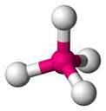

Answer: Tetrahedral

A 500 point question might look like this: What is the electron configuration of the N atom?

Answer: 1s22s22p3

Scoring

Details provided based on puzzle.